
Suite 2.12, Level 2. TRN House
90 Podium way, Oran Park 2570 P: 02 4607 5010 F: 02 4607 5011 E: reception@swcpc.com.au.

Preparing for your Home-Based Sleep Study appointment
A sleep study is a test that monitors the following overnight whist you sleep

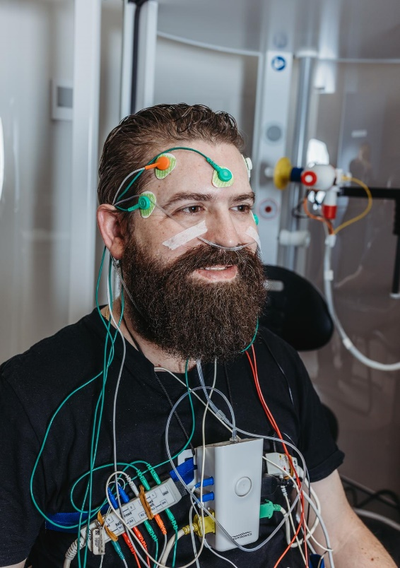
- Eye Movement (EOG)
- Brain Signals (EEG)
- Muscle tone (EMG)
- Heart (ECG)
- Breathing
- Chest and abdominal movements
- Oxygen levels
To monitor these, we will attach numerous sensors on your head, face, chest, and legs. You will also have a band around your chest and abdomen, finger probe and a couple of sensors that sit just inside your nostrils.

What do I need to do on the day?
Once we set you up with the equipment, you will be unable to remove any clothing on the top half of your body until the following morning. These instructions are not only for your comfort but are also important for the accuracy of the sleep study. Additionally:
- Allow one hour for the appointment.
- Shower, ensuring to clean behind your ears, wash your hair and remove any make-up before your appointment.
- Try to be clean-shaven (at least under your jaw line) if you have facial hair.
- Attend your appointment in a top/shirt that you will feel comfortable to sleep in.
- Remove fingernail polish (including shellac or acrylics) off the left index finger
- Advise your consultant if you have any skin allergies.

On the night of your home-based sleep study:
- Before you go to sleep, ensure the nasal tube and finger probe are firmly in place.
- Sleep as your normally would, including time, body position, eating and drinking habits
- If you notice the testing device flashing with a light, do not worry this is normal. Continue to try to sleep if you notice this during the night, as the test will still record.

Removing the equipment, the morning after your home-based sleep study:
- Do not unplug any wires from the main testing unit — this may damage the device.
- Do NOT cut any of the electrodes.
- Remove the finger probe and nasal tube.
- Remove leg strap
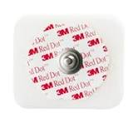
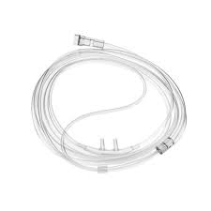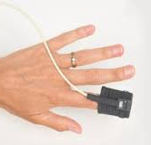
- Remove the sticky electrodes attached to your skin. The sticky part may be unclipped from the wire like a button and thrown away.
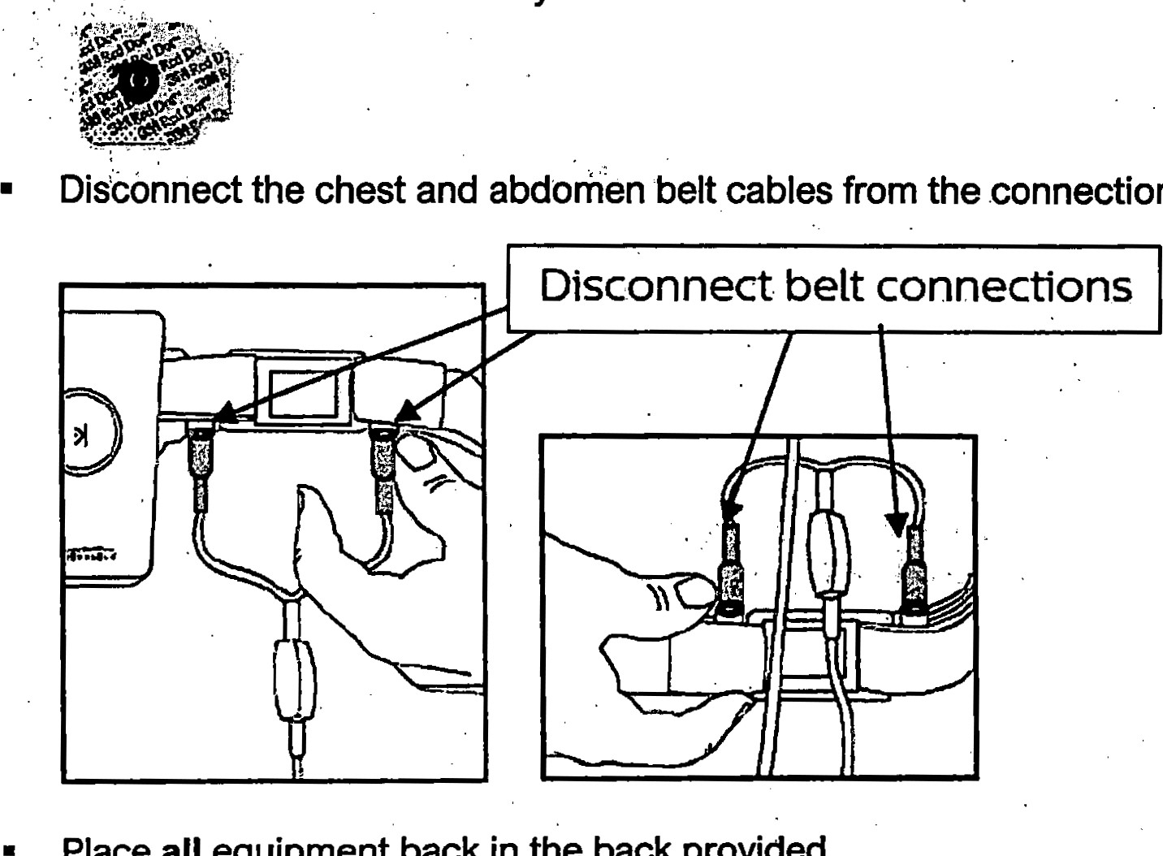

- Disconnect the chest and abdomen belt cables from the connections
- Place all equipment back in the pack provided
- Ensure you have completed both the pre and post sleep questionnaires before returning to the clinic
Returning the unit:
- The device will need to be returned at the clinic usually by 10 am the next morning.
- Your results will be finalised approximately 2-3 weeks after your test. Your specialist will discuss the results with you at your follow up appointment. A report will also be sent to your referring doctor.
- Please do not hesitate to call the clinic (02 4607 5010) if you have any questions

